From: <https://www.unz.com/article/russias-neo-byzantinism/>

Russia's Neo-Byzantinism

By: LAURENT GUYÉNOT • Date: DECEMBER 30, 2022 • 4,300 WORDS • 233 COMMENTS • 7 SHARES

Search Text RSS

TABLE OF CONTENTS

Russia's Neo-Byzantinism

Pan-Slavism and Eurasianism

Orthodoxy and Byzantinism

Keywords: Byzantinism (14 results), Putinism (2 results),

[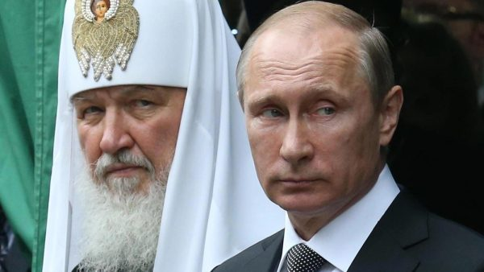](https://www.unz.com/article/russias-neo-byzantinism/)

There is something irresistibly attractive in **Russia’s defense of traditional and religious values** (what might be called Russian neo-conservatism if that label had not been usurped by American Jewish warmongers). But where does it really come from? We tend to assume that it is a reaction to Western post-modern decadence. But there is more depth to it.

What is Russia? How does Russia define herself, and how does she conceive of her relationship to Europe? Specifically, **from what tradition do Russia’s current ruling elites draw their vision of Russian civilization?** I wanted to learn about the Russian thinkers of the nineteenth and twentieth centuries that the Russians themselves have rediscovered since the fall of Communism, and who are said to have a strong influence on Vladimir Putin and his entourage. Here is what I found.

Let’s start, quite logically, with three authors whose books were offered by Vladimir Putin to governors and members of his United Russia party for the New Year 2014 (see [**here**](https://www.thepostil.com/the-philosophical-sources-of-putins-thinking/) and [**here**](https://www.academia.edu/37635783/Putins_Political_Philosophers_Neo_Orthodoxy_Identitarianism_and_the_Russian_Federation)):

* Vladimir Solovyov’s *The Justification of the Good*
* Nikolai Berdyaev ‘s *The Philosophy of Inequality*
* Ivan Ilyin’s *Our Tasks*

All three authors are deeply religious and patriotic, and as such committed to Russian Orthodoxy. All three are passionate about Russia, and hold her as “an original and independent civilization,” in the terms used by Vladimir Putin in his [**October 27, 2022 speech at the Valdai Forum**](https://www.miragenews.com/full-text-of-putin-speech-and-answers-at-valdai-884161/)*.*

## Vladimir Solovyov’s The Justification of the Good

Soloviev or Solovyov (1853-1900) was a poet, philosopher, theologian and mystic, specially known for his “Sophiology”, a theory of Wisdom as the Feminine World Principle, which Soloviev encountered mystically (I have mentioned it in an earlier article). His book [***The Justification of the Good: An Essay on Moral Philosophy***](https://archive.org/details/thejustification00solouoft), written in 1897, is an attempt to found moral values on a scientific basis, by showing that they are anchored in three impulses of the mind common to all peoples: shame, pity and reverence. Shame causes us not to identify with our base instincts, and manifests itself in modesty; pity is compassion for our equals; reverence, which is the foundation of social hierarchy and religion, is love for superior beings. I will not dwell on this book, which, unlike the other two, does not have a strong political dimension.

## Nikolai Berdyaev ‘s The Philosophy of Inequality

Nicolas Berdyaev (1874-1948) is one of the most accessible Russian philosophers, especially to French readers, because he lived in France and died there, and most of his writings have been translated. He contributed to introduce other like-minded Russian thinkers like Konstantin Leontiev or Alexis Khomiakov, whom I will talk about later. His book [***The Philosophy of Inequality: Letters to my Contempters Concerning Social Philosophy***](https://www.amazon.com/Philosophy-Inequality-Letters-Contemners-Concerning/dp/0996399208), written in 1918, is a harsh critique of the paradigms of Western political thought. Berdyaev has a mystical and supernatural conception of power: “The principle of power, he writes, is entirely irrational. … no one in the world has ever submitted to any power for rational reasons.” Power is always personal. That is why democracy — the Rousseauist utopia of the sovereignty of the people — is a lie. “Since the creation of the world, it is always the minority which has governed, which governs and which will govern. … The only question is whether it is the better or the worse minority that governs.” The government of the best, that is to say aristocracy in the proper sense, is “a higher principle of social life, the only utopia worthy of man.” The triumph of democratism “represents the greatest danger to human progress, to the qualitative elevation of human nature.”[**[1]**](https://www.unz.com/article/russias-neo-byzantinism/#footnote_1) It is the worship of an empty idea, the deification of human arbitrariness.

## Ivan Ilyin’s *Our Tasks*

Ivan Ilyin (1884-1954) is the political thinker [**most often mentioned**](https://www.nybooks.com/online/2018/03/16/ivan-ilyin-putins-philosopher-of-russian-fascism/) as having an influence on Putin. Arrested six times by the Bolsheviks, he was finally exiled in 1922 by Lenin, on the famous [**“philosophers’ ships”**](https://en.wikipedia.org/wiki/Philosophers'_ships) among 160 other intellectuals, including Berdyaev. Like Berdyaev, **Ilyin saw Soviet Communism as inherently evil**, because of its

* metaphysical materialism and
* destruction of religious life.

In the opening pages of [***On Resistance to Evil by Force***](https://www.amazon.com/Resistance-Evil-Force-Ivan-Ilyin/dp/1726472043) (a critic of the pacifism of Tolstoy and his disciples, and a message to the “White warriors, bearers of the Orthodox sword”, written in 1925), Ilyin writes:

As a result of a long brewing process, evil has now managed to free itself from all internal divisions and external obstacles, show its face, spread its wings, utter its goals, muster its forces, realize its ways and means; moreover, it has openly legitimated itself, formulated its dogmas and canons, praised its own no longer hidden disposition, and revealed to the world its spiritual nature. Nothing equivalent or equal to this has been seen in the history of humanity, at least as far as can be remembered.[**[2]**](https://www.unz.com/article/russias-neo-byzantinism/#footnote_2)

While living in Germany, Ilyin had expressed some support for National Socialism in *1933,* with an essay titled “National Socialism: ‘A New Spirit’.” However, he was soon disappointed by Hitler’s racial policy and moved to Switzerland, where he died. At Putin’s initiative, his body was repatriated to Russia in 2005 and buried in the Donskoy monastery.

**[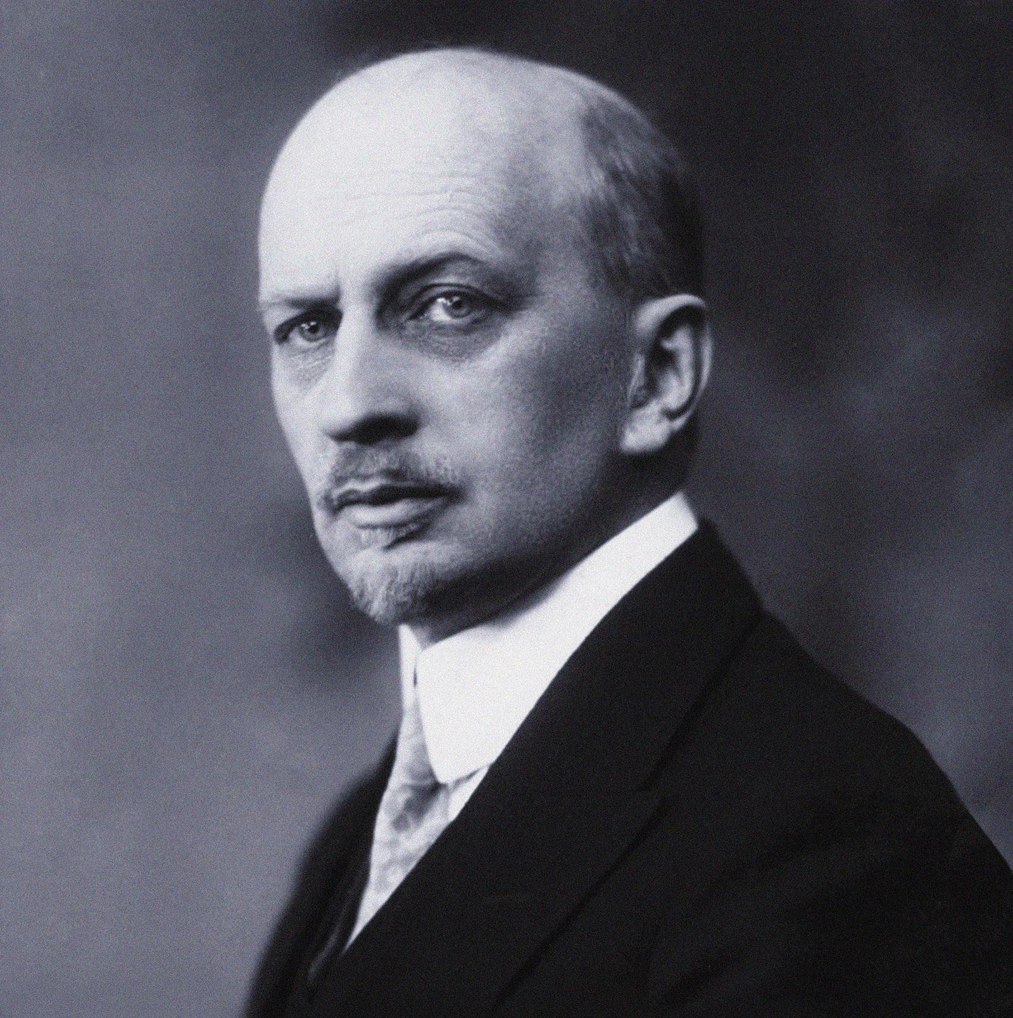](https://www.unz.com/wp-content/uploads/2022/12/RussiaByzantineLG-2.jpg)**

*Our Tasks*is a two-volume collection of articles smuggled into Soviet Russia between 1948 and 1954. Ilyin set a program for rebuilding Russia after the collapse of the Soviet regime, which he hoped was near. **With prophetic accuracy, he warned the Russians about the designs of the West on the dismemberment of the Russian state.** The West, he understood, **dreams of carving up Russia into “a giant Balkans”**, a tragedy which would produce irreparable global chaos. Putin’s description of the collapse of the Soviet Union as “the greatest geopolitical catastrophe of modern times” echoes Ilyin’s words. The translator of Ilyin’s *On Resistance to Evil by Force*, wrote:

Another important contribution of Ilyin was his concept of t**he “world backstage”, the cosmopolitan forces which controlled European powers from the shadows, and had as their intention the dissection and destruction of the Russian state.** Thus, he deepened the Russian understanding of contemporary political developments and the rise of non-state actors, making clear that the Bolshevik Revolution had not been a native uprising, but a meticulously planned foreign plot.[**[3]**](https://www.unz.com/article/russias-neo-byzantinism/#footnote_3)

Like Berdyaev, Ilyin has Russia’s post-Soviet rebirth in mind, and for this he seeks to understand and explain the deeper nature of Russia and her ideal type of government. He advocates a third way between democracy and totalitarianism, which he defines as “a firm, national-patriotic dictatorship inspired by the liberal idea.” A new idea is needed, he claimed, for **a new Russia**.

This idea should be

* state-historical,
* state-national,
* state-patriotic,
* state-religious.

This idea should stem from the very fabric of Russian soul and Russian history, from its spiritual hunger. This idea should speak of the essence of Russians — both of the past and of the future — it should light the way for the generations of Russians to come, giving meaning to their lives and giving them vigor.[**[4]**](https://www.unz.com/article/russias-neo-byzantinism/#footnote_4)

This idea has to be firmly ingrained in a layer of enlightened and determined patriots who would be ready take the reins of Russia and save her from dismemberment by the West.

We do not know when or how the Communist revolution in Russia will be interrupted. But we know what is the main task of salvation and Russian national reconstruction: the ascension to the top of the best, men committed to Russia, who feel their nation, who think about their State, voluntary, creative, who offer the people not revenge and decadence, but the spirit of liberation, justice and union between all classes. If the election of these new Russian men is a success and is achieved quickly, Russia will rise and be reborn in a few years. If this is not the case, Russia will fall into revolutionary chaos in a long period of post-revolutionary demoralization, decadence and dependence on the outside.[**[5]**](https://www.unz.com/article/russias-neo-byzantinism/#footnote_5)

The head of the government that could rescue Russia from chaos, writes Ilyin, “must be guided by the idea of the Whole, and not by particular, personal or partisan motives.” And he should not refrain from violence: “He strikes the enemy instead of wasting time.”[**[6]**](https://www.unz.com/article/russias-neo-byzantinism/#footnote_6)

## Pan-Slavism and Eurasianism

**[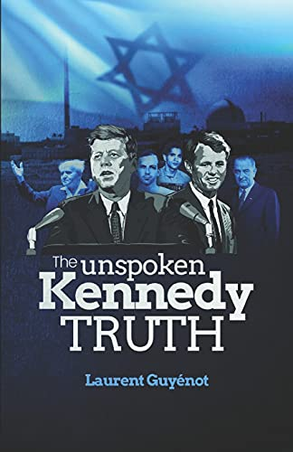](https://www.amazon.com/dp/2957170418/)**

Soloviev, Berdiaev and Ilyin were all writing during a century of great intellectual creativity in Russia. The defeat of Napoleon in 1815 had established Russia as one of the Great Powers at the Congress of Vienna. Yet in the following decades, Russians became frustrated by what they perceived as the West’s persisting hostility and contempt. This gave birth in 1830s and 1840s to the intellectual movement of the “Slavophiles”, who opposed the infatuation of the “Westernizers” for European culture and sought to define Russia’s unique identity and destiny.

During the Crimean War (1853-1856), Russians were shocked to find Catholic and Protestant powers allying with the Muslim Empire against Christian Russia. Twenty years later, Tsar Alexander II, acting as protector of Christian nations, once again went to war against the Ottomans who had just drowned the uprising of the Serbs and the Bulgarians in a bloodbath. By the Treaty of San Stefano (1878), the Tsar

1. founded the autonomous principalities of Bulgaria, Serbia and Romania, and
2. amputated the Ottoman Empire of territories populated by Georgians and Armenians.

But the Europeans again opposed this redistribution and convened the Congress of Berlin (1885), which amputated the Russian conquests, and returned most of Armenia, as well as part of Bulgaria, to the Ottoman Empire. **Russia had won the war but lost the peace.** The independent principalities of the Balkans are fragmented into small, weak, rival and ethnically divided states — **a “balkanization” that will contribute to the outbreak of the First World War.**

These episodes left a bitter taste to Russian patriots. **Fyodor Dostoevsky** *(1821-1881)* expressed his frustration in his final year:

was there a limit to our efforts to make Europe recognize us as hers, as Europeans, solely as Europeans, and not Tartars? Continually and incessantly we have annoyed Europe, meddling with her affairs and petty business. Now, we scared her with our strength, dispatching our armies “to save the kings,” now we bowed before Europe — which we shouldn’t have done — assuring her that we were created solely for the purpose of serving her and making her happy.[**[7]**](https://www.unz.com/article/russias-neo-byzantinism/#footnote_7)

His contemporary Nicolai Danilevskii (1822-1885) reflected on this whole situation in [***Russia and Europe***](http://russia_and_europe_the_slavic_worlds_political_and_cultural_relations_with_the_germanic_roman_west_by_nikolai_iakovlevich_danilevskii_translated_and_annotated_by_stephen_m_woodburn_/) (1869) As his recent translator [**Stephen Woodburn writes**](https://slavica.indiana.edu/sites/default/files/bookContent_pdf/Introduction.pdf):

The blatant hypocrisy of Europe’s aggressive response in the Crimean War to the expansion of Russian influence, and its benign indulgence of naked German aggression against Denmark ten years later, obviously failed the test of rationality. Something irrational was afoot, and Danilevskii introduced his book as an attempt to explain what that was.[**[8]**](https://www.unz.com/article/russias-neo-byzantinism/#footnote_8)

Realizing that all Russian efforts to befriend Europe were met with deception or rejection, Danilevskii called his fellow citizens to admit that Europe and Russia were fundamentally foreign to each other: “Neither true modesty nor true pride would allow Russia to claim to be Europe. It did nothing to deserve that honor, and if it wants to deserve a different one, it should not claim what it does not deserve.”[**[9]**](https://www.unz.com/article/russias-neo-byzantinism/#footnote_9) **Russia and Western Europe do not share any common history, except marginally, and their characters were shaped by completely different circumstances.** Born under the tutelage of Byzantium and growing up in the shadow of Sarai (the capital of the Golden Horde), Russia knew nothing of

* feudalism,
* Latin culture,
* Scholasticism or
* the Renaissance.

Putin seemed to echo Danilevskii when he stated in his [**2012 state-of-the-federation address**](http://eng.kremlin.ru/transcripts/4739): “In order to revive national consciousness, we need to link historical eras and get back to understanding **the simple truth that Russia did not begin in 1917, or even in 1991, but, rather, that we have a common, continuous history spanning over 1,000 years and we must rely on it to find inner strength and purpose in our national development.**”

A biologist by training, Danilevskii developed the earliest organic theory of civilizations, which may have influenced Spengler. According to him, each civilization has its own development, based on its own ethnic nature, itself shaped by geography. Russian identity, according to Danilevskii, is “Slavdom”. That is why Russia must,

* on the one hand, protect herself from the influence of Germano-Roman culture, which can only disturb its natural development, and
* on the other hand, unite in one great civilization all the Slavic countries.

Danilevskii was writing when the unification of the German states under Prussian leadership was nearly complete, and he admired Bismarck’s principled ambition and pragmatic opportunism. He also saw the need for a strong Slavic federation under Russian leadership to counterbalance the hegemony of Western Europe. “The struggle against the West, he wrote, is the only saving means for the healing of our Russian culture.”[**[10]**](https://www.unz.com/article/russias-neo-byzantinism/#footnote_10)

Danilevskii’s book was an important landmark in the nineteenth century, but its limited circulation at that time cannot be compared with the number of editions that has been printed *s*ince the 1990s. After a 1991 edition printed for 70,000 copies, which was made required reading at Russian military academies,**[[11]](https://www.unz.com/article/russias-neo-byzantinism/" \l "footnote_11)** a deluxe edition of 20,000 copies appeared in 1995, followed by four new editions between 2002 and 2010.

Despite the merits of Danilevskii as a pioneer of geopolitical analysis, his ethnically based pan-Slavic project raised skepticism. Konstantin Leontiev (1831-1891), nine years younger than him, objected in *Byzantinism and Slavdom*that

* Slavic countries do not share a common history.
* Catholic Poland has always been the mortal enemy of Russia.
* The Czechs, whether Catholic or Protestant, are deeply Germanized,
* while the Bulgarians are culturally close to the Greeks.
* Hungary and Romania are closer to Russia, but are not Slavic.

Today, only Serbia, Belarus (White Russia) and East Ukraine (Little Russia) could be regarded as belonging to the same civilization as Great Russia.

**[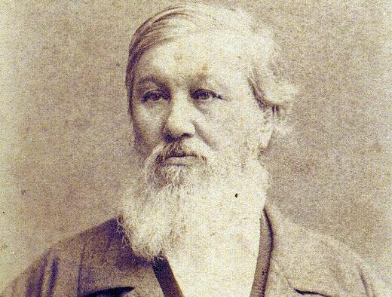](https://www.unz.com/wp-content/uploads/2022/12/RussiaByzantineLG-3.jpg)**

Danilevskii’s assessment of Slavdom also lacks consideration for the Asian influence on Russians, which Leontiev was one of the first to emphasize. It became a subject of study two generations later, with the pioneering work of the linguist Nikolai Trubetzkoy (1890-1938), whose major articles are collected in the volume titled [***The Legacy of Genghis Khan***](https://www.academia.edu/32890252/THE_LEGACY_OF_GENGHIS_KHAN_THE_MONGOL_IMPACT_ON_RUSSIAN_HISTORY_POLITICS_ECONOMY_AND_CULTURE) (1925), and made him a founder of **Eurasianism**. He writes:

from an ethnographic point of view, the Russian people are not purely Slavic. The Russians, the Ugro Finns, and the Volga Turks comprise a cultural zone that has connections with both the Slavs and the “Turanian East,” and it is difficult to say which of these is more important. The connection between the Russians and the Turanians has not only an ethnographic but an anthropological basis: Turkic blood mingles in Russian veins with that of the Ugro-Finns and Slavs. And the Russian national character is unquestionably linked in certain ways with the “Turanian East.” The brotherhood and mutual understanding that develop so quickly between us and “Asians” are rooted in these invisible racial consonances.[**[12]**](https://www.unz.com/article/russias-neo-byzantinism/#footnote_12)

Like [**Lev Gumilev**](https://www.unz.com/article/lev-gumilev-and-the-khazar-chimera/) (1912-1992) after him, Trubetzkoy also argued that the unification of the territory of modern Russia under one state was first achieved not by Russian Slavs, but by the Tatars (or Turano-Mongols). Ultimately, “the political unification of Russia under the power of Moscow was a direct result of the Tatar Yoke.” Although traumatic, the Tatar Yoke forged Russian nationality.

Thus, in reaction to the despair occasioned by total defeat at the hands of the Tatars, a wave of heroism — primarily religious but also nationalistic — was growing and gaining strength in Russian hearts and minds.

The center of the process of inner rebirth was **Moscow**. All the phenomena brought into existence by the Tatar Yoke resonated there with exceptional force. … Russians in this area assimilated more easily and quickly the spirit of the Mongolian state, that is, the ideational legacy of Genghis Khan. It was also Moscow and the Moscow region that exhibited particular interest in Byzantine state ideologies.[**[13]**](https://www.unz.com/article/russias-neo-byzantinism/#footnote_13)

**Putin clearly supports Eurasianism rather than** pan-Slavism. Yet, he does not refrain from stressing that the “the [ethnic] Russian people are, without a doubt, the backbone, the fundament, the cement of the multinational Russian people.”[**[14]**](https://www.unz.com/article/russias-neo-byzantinism/#footnote_14)

## [Orthodoxy and Byzantinism](https://www.unz.com/article/russias-neo-byzantinism/#orthodoxy-and-byzantinism)

**[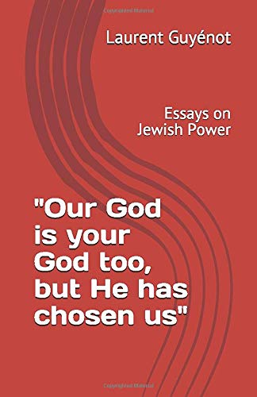](https://www.amazon.com/dp/295717040X/)**

The early founders of the Slavophile movement, such as Alexis Khomiakov (1804-1860), insisted on religion, rather than ethnicity, as the main ingredient of civilization. For Khomiakov, Orthodoxy is the very soul of Russia, and what sets Russians apart from Western peoples, whether Catholics or Protestants. In the Greek Orthodox tradition, the Church is the community of believers, united in the love of Christ. This is why all Russians, from peasants to boyars, will make any sacrifice to defend the Church. From the eleventh century, the Roman papacy destroyed this spiritual communion by imposing a radical separation between the institutional Church and lay people, so that “the Christian was no longer a member of the Church, but a subject of it.”[**[15]**](https://www.unz.com/article/russias-neo-byzantinism/#footnote_15)

The divergences between Roman Catholicism and Greek Orthodoxy, and their effects on the collective souls of peoples, is a rich and complex subject on which I cannot dwell here. What is most important to understand is that these are not simply doctrinal or liturgical differences; **there is a fundamental difference of political philosophy**. The struggle for papal supremacy, which is rooted in Augustine’s theories and which dominated West European history since the beginning of the Gregorian reform (eleventh century), is a radical departure from the Orthodox tradition established in Constantinople in the fourth century, which Catholics deride as “caesaropapism”.[**[16]**](https://www.unz.com/article/russias-neo-byzantinism/#footnote_16)

This is why Konstantin Leontiev, one of the most influential Russian political philosophers, characterized the essence of Russia as “**Byzantinism**” rather than simply Orthodoxy. Russia is heir to Byzantine civilization in its intricate political and religious aspects. In his book ***[Byzantinism and Slavdom](https://www.amazon.com/Byzantinism-Slavdom-Konstantin-Leontiev/dp/B08LNLCLCL/ref=sr_1_1?crid=3JWFCCGQJUFB7&keywords=Leontiev&qid=1672311229&sprefix=leontiev%2Caps%2C156&sr=8-1" \o "https://www.amazon.com/Byzantinism-Slavdom-Konstantin-Leontiev/dp/B08LNLCLCL/ref=sr_1_1?crid=3JWFCCGQJUFB7&keywords=Leontiev&qid=1672311229&sprefix=leontiev%2Caps%2C156&sr=8-1)****,* published in 1875, Leontiev defines Byzantinism as, essentially, autocratic despotism sanctified by the Church: “from whatever angle we examine the life and state of Great Russia, we will see that Byzantinism, that is, Church and the tsar, whether directly or indirectly, penetrate deeply into the very subsoil of our social organism.”[**[17]**](https://www.unz.com/article/russias-neo-byzantinism/#footnote_17)

Russia’s traditional attachment to Byzantinism has much to do with her **sense of mission to collect and save the heritage of the Eastern Roman Empire** assassinated by the international brigades of the Pope under the pretext of liberating the East from Islam, when the Frankish crusaders sacked Constantinople in 1205. This mortal wound, from which Byzantium would never recover, Westerners have carefully repressed it from their collective memory, but Russians have engraved it in theirs. It resonated with another cornerstone of their national narrative, the victory of their national saint and hero Alexander Nevski against other crusaders in 1242. As *Nikolai*Trubetzkoy points out, Russia’s identification with Orthodoxy was deepened and strengthened during the humiliation of the Tatar Yoke, even benefitting from the khans’ religious tolerance and support of the Church.

let us remember that Russia had come to know Orthodox Byzantium long before the Tatar Yoke and that during the time of the Yoke the grandeur of Byzantium was in eclipse; yet for some reason it was during the period of Tatar rule that Byzantine state ideologies, which formerly had no particular appeal in Russia, came to occupy a central place in the Russian national consciousness. It follows that the grafting of these ideologies onto Russia was not motivated by the prestige of Byzantium, and that they were needed only to link an idea of the state, Mongolian in origin, to Orthodoxy, thereby making it Russian. So it was that this idea was absorbed, an idea which Russians had encountered in real life after their land was incorporated into the Mongolian empire and became one of its provinces.[**[18]**](https://www.unz.com/article/russias-neo-byzantinism/#footnote_18)

For Russians, **the betrayals of the West since the nineteenth century are only the repetition of a pattern that started in medieval times.** This is precisely the argument of the film [**“The fall of an Empire: the Lesson of Byzantium”**](https://www.youtube.com/watch?v=f1CWG-2GLU4), aired on the Russian government-controlled television station Rossiia (RTR) on January 31, 2008. It was produced, directed and narrated by Father Tikhon Shevkunov, head of the Sretenskii monastery in Moscow, and a friend of Putin. In the film, the collapse of the Eastern Roman Empire is attributed to corrupt domestic oligarchs and the pernicious actions of the West. The story of Byzantium is explicitly presented as a warning for Russia’s contemporary rulers: they are exhorted to **rein in the oligarchs, fortify the ramparts against the West, or face destruction.** As I wrote in an [**earlier article**](https://www.unz.com/article/a-byzantine-view-of-russia-and-europe/), we Westerners don’t know what Russia is, because we don’t know what Byzantium is.

**[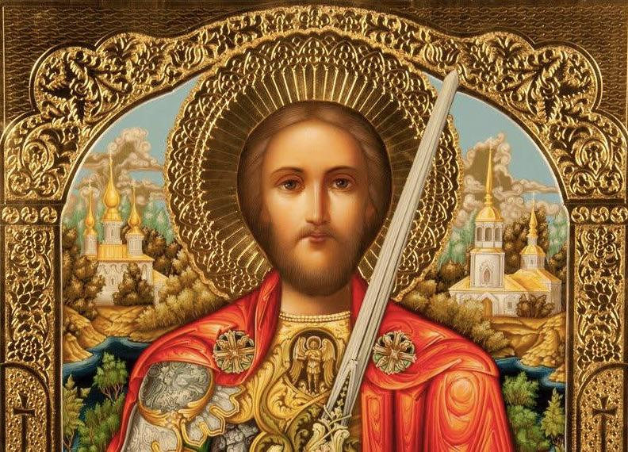](https://www.unz.com/wp-content/uploads/2022/12/RussiaByzantineLG-4.jpg)**

In the mid-nineteenth century, Russian patriots were passionate about Russia’s mission, not only as heir, but as liberator of Constantinople. Already Catherine II, Empress of all the Russias from 1762 to her death in 1796, had hoped to rebuild the Byzantine Empire by including Greece, Thrace and Bulgaria, and pass it on to her grandson, predestined by his name Constantine.

In 1877, Dostoevsky told his readers again and again, “Constantinople must be ours.” Since Russia “unhesitatingly accepted the banner of the East, **having placed** [**the Byzantine double eagle**](https://www.google.com/search?q=the+Byzantine+double+eagle&oq=the+Byzantine+double+eagle&aqs=chrome..69i57j69i64.1324j0j15&sourceid=chrome&ie=UTF-8) **over and above its ancient coat-of-arms**,” she assumed the responsibility of liberating Constantinople, also known as Tsargrad:

Constantinople must be ours, conquered by us, Russians, from the Turks, and remain ours forever. She must belong to us alone, and possessing her we may, of course, admit into her all Slavs and, in addition, anyone whom we please, on the broadest basis.[**[19]**](https://www.unz.com/article/russias-neo-byzantinism/#footnote_19)

There is, of course, no Russian plan to conquer Istanbul today. Rather, steps are taken for a long-term constructive relationship between those two civilizations, based on a mutual recognition of their shared Byzantine heritage. As a matter of fact, Erdoğan’s Turkey is slowly but surely moving toward Byzantinism, in the broad sense of a close alliance between state and church. And of course, Iran has been traveling this road since 1979. As for [**China under Xi Jinping**](https://www.economist.com/the-economist-explains/2021/06/23/how-did-confucianism-win-back-the-chinese-communist-party), it is injecting a good dose of neo-Confusianism in its State ideology. The emerging multipolar world order might well turn out a Byzantine mosaic.

Byzantinism is, in any case, the model of Putin’s Russia, We might call it Ilyinism, but it seems to be in fact a shared conviction of all major Russian philosophers of the last two centuries, including *Dostoevsky.*

John Schindler, a former professor at the U.S. Navy War College, wrote in a 2014 piece for the *National Review Online*, titled [**“Putinism and the anti-WEIRD Coalition”**](https://predicthistunpredictpast.blogspot.com/2014/04/putinism-and-anti-weird-coalition.html) (in which WEIRD stands for “Western, Educated, Industrialized, Rich and Democratic”):

Putinism includes a good amount of Ilyin-inspired Orthodoxy and Russian nationalism working hand-in-glove, what its advocates term *symphonia*, meaning the Byzantine-style unity of state and church, in stark contrast to American notions of separation of church and state. Although the Russian Orthodox Church (ROC) is not the state church, de jure, in practice it functions as something close to one, enjoying a privileged position at home and abroad. Putin has explained the central role of the ROC by stating that Russia’s “spiritual shield” — meaning her church-grounded resistance to post-modernism — is as important to her security as her nuclear shield. Meanwhile, Kremlin security agencies have publicly embraced Orthodoxy too, with the FSB espousing a doctrine of “spiritual security,” which boils down to the ROC and the “special services” working together against the West and its malign influences.

As Schindler correctly notes, Westerners who are horrified by Putin’s reactionary conservatism only have to blame themselves for it.

When Washington, DC, considers having successful gay pride parades a key benchmark for “advancement” in Eastern Europe, [**with the full support of U.S. diplomats**](https://mpetrelis.blogspot.com/2011/09/us-embassy-in-belgrades-warning-on.html), we should not be surprised when the Kremlin and its sympathizers move to counter this.

By its crusade for sexual deviancy the West is, dialectically, making Russian conservatism more and more attractive to decent peoples. “One of the big talking points from the Kremlin and the ROC is that Russia represents the actual global The West is definitely the world’s WEIRDo, and has already lost the battle for the minds.consensus on such matters, while the West is the decadent outlier.”

**Notes**

[**[1]**](https://www.unz.com/article/russias-neo-byzantinism/#footnoteref_1) My translation from the French edition, Nicolas Berdiaev, *De l’inégalité,* L’Âge d’homme, 2008, p. 132.

[**[2]**](https://www.unz.com/article/russias-neo-byzantinism/#footnoteref_2) *Ivan Aleandrovich Ilyin,*[***On Resistance to Evil by Force***](https://www.amazon.com/Resistance-Evil-Force-Ivan-Ilyin/dp/1726472043)*, Taxiarch Press, 2018, pp. 1, 3.*

[**[3]**](https://www.unz.com/article/russias-neo-byzantinism/#footnoteref_3) *K. Benois, “About the Author,”, in Ivan Aleandrovich Ilyin,*[***On Resistance to Evil by Force***](https://www.amazon.com/Resistance-Evil-Force-Ivan-Ilyin/dp/1726472043)*, Taxiarch Press, 2018, p. vi.*

[**[4]**](https://www.unz.com/article/russias-neo-byzantinism/#footnoteref_4) Quoted from Anton Barbashin, “Ivan Ilyin: A Fashionable Fascist,” April 20, 2018 on [**https://ridl.io/ivan-ilyin-a-fashionable-fascist/**](https://www.unz.com/h)

[**[5]**](https://www.unz.com/article/russias-neo-byzantinism/#footnoteref_5) Quoted in *Michel Eltchaninoff, Dans la tête de Vladimir Poutine, Actes Sud, 2022, pp. 52-53. I have used the translation from*[***www.thepostil.com/the-philosophical-sources-of-putins-thinking/***](http://www.thepostil.com/the-philosophical-sources-of-putins-thinking/)

[**[6]**](https://www.unz.com/article/russias-neo-byzantinism/#footnoteref_6) Quoted by Étienne de Floirac in “The Philosophical Sources of Putin’s Thinking,” May 1, 2022, on [**www.thepostil.com/the-philosophical-sources-of-putins-thinking/**](https://www.thepostil.com/the-philosophical-sources-of-putins-thinking/)

[**[7]**](https://www.unz.com/article/russias-neo-byzantinism/#footnoteref_7) *Fyodor Dostoievsky, The Diary of a Writer, trans. Boris Brasol, Charles Scribner’s Sons, 1919, p. 1045.*

[**[8]**](https://www.unz.com/article/russias-neo-byzantinism/#footnoteref_8) Stephen M. Woodburn, “Translator’s Introduction”, in Nicolai Iakovlevich Danilevskii,*Russia and Europe: The Slavic World’s Political and Cultural Relations with the Germanic-Roman West,* Slavica Publishers, 2013, p. xix.

[**[9]**](https://www.unz.com/article/russias-neo-byzantinism/#footnoteref_9) *Ibid.*, p. xx.

[**[10]**](https://www.unz.com/article/russias-neo-byzantinism/#footnoteref_10) Quoted by Étienne de Floirac in “The Philosophical Sources of Putin’s Thinking,” May 1, 2022, on [**www.thepostil.com/the-philosophical-sources-of-putins-thinking/**](https://www.thepostil.com/the-philosophical-sources-of-putins-thinking/)

[**[11]**](https://www.unz.com/article/russias-neo-byzantinism/#footnoteref_11) **J. L. Black,** [***Russia Faces NATO Expansion: Bearing Gifts or Bearing Arms?***](https://www.unz.com/h) *Rowman & Littlefield Publishers, 2000, p. 5 (reviewed here:*[***https://networks.h-net.org/node/10000/reviews/10225/granville-black-russia-faces-nato-expansion-bearing-gifts-or-bearing)***](https://networks.h-net.org/node/10000/reviews/10225/granville-black-russia-faces-nato-expansion-bearing-gifts-or-bearing))

[**[12]**](https://www.unz.com/article/russias-neo-byzantinism/#footnoteref_12) *Nikolai Sergeevich Trubetzkoy, The Legacy of Genghis Khan and Other Essays on Russia’s Identity, Michigan Slavic Publications, 1991,*p. 96.

[**[13]**](https://www.unz.com/article/russias-neo-byzantinism/#footnoteref_13) *Nikolai Sergeevich Trubetzkoy, The Legacy of Genghis Khan and Other Essays on Russia’s Identity, Michigan Slavic Publications, 1991,*pp. 177, 181.

[**[14]**](https://www.unz.com/article/russias-neo-byzantinism/#footnoteref_14) *Mark Galeotti, “Putin’s Empire of the Mind.*How Russia’s president morphed from realist to ideologue — and what he’ll do next,” April 21, 2014, on [**foreignpolicy.com/2014/04/21/putins-empire-of-the-mind/**](https://foreignpolicy.com/2014/04/21/putins-empire-of-the-mind/)

[**[15]**](https://www.unz.com/article/russias-neo-byzantinism/#footnoteref_15) Translated from Alexeï Khomiakov, ***[L’Église latine et le protestantisme au point de vue de l’Église d’Orient](https://www.amazon.fr/LEglise-latine-Protestantisme-lEglise-dOrient/dp/2888920018/ref=sr_1_1?__mk_fr_FR=%C3%85M%C3%85%C5%BD%C3%95%C3%91&crid=8OK3UPKH66P1&keywords=L%E2%80%99%C3%89glise+latine+et+le+protestantisme+au+point+de+vue+de+l%27%C3%89glise+d%27Orient&qid=1671887334&sprefix=l+%C3%A9glise+latine+et+le+protestantisme+au+point+de+vue+de+l%27%C3%A9glise+d%27orient%2Caps%2C72&sr=8-1" \o "https://www.amazon.fr/LEglise-latine-Protestantisme-lEglise-dOrient/dp/2888920018/ref=sr_1_1?__mk_fr_FR=ÅMÅŽÕÑ&crid=8OK3UPKH66P1&keywords=L’Église+latine+et+le+protestantisme+au+point+de+vue+de+l'Église+d'Orient&qid=1671887334&sprefix=l+église+latine+et+le+protestantisme+au+point+de+vue+de+l'église+d'orient%2Caps%2C72&sr=8-1)****, Lausanne, 1872, p. 38.*

[**[16]**](https://www.unz.com/article/russias-neo-byzantinism/#footnoteref_16) Henri-Xavier Arquillière, *L’Augustinisme politique. Essai sur la Formation des théories politiques du Moyen-Âge,*Librairie philosophique J. Vrin, 1972.

[**[17]**](https://www.unz.com/article/russias-neo-byzantinism/#footnoteref_17) Konstantin Leontiev, *Byzantinism and Slavdom,*Taxiarch Press, 2020, p. 33.

[**[18]**](https://www.unz.com/article/russias-neo-byzantinism/#footnoteref_18) *Nikolai Sergeevich Trubetzkoy, The Legacy of Genghis Khan and Other Essays on Russia’s Identity, Michigan Slavic Publications, 1991,*p. 181.

[**[19]**](https://www.unz.com/article/russias-neo-byzantinism/#footnoteref_19) *Fyodor Dostoievsky, The Diary of a Writer, trans. Boris Brasol, Charles Scribner’s Sons, 1919, pp. 629, 904.*